**LINUX COMMANDS**

**Experiment No: 1 Date: 31/07/2023**

**AIM:** To study basic Linux commands.

**THEORY:**

1) date : display system date and time.

2) cal : display calendar.

3) who : display all users of system.

4) whoami : display identity of user who has given command.

5) ps : use for viewing processes.

6) ls : list all files and folder in current working directory.

7) ls –l : display list of files and directory along with existing right.

8) cat filename : display content of file.

9) cat >filename : creates a file and allows to enter content.

10) cat >>filename : append content at end of file.

11) wc filename : display no. lines,words,character.

12) wc -w filename : no. of words.

13) wc -l filename : no. of lines.

14) wc –c filename : no. of characters.

15) uname : displays features of operating system.

16) tty : gives identity of terminal on which we are working.

17) pwd : display directory.

18) stty : change and display terminal settings.

19) rm filename : removes/delete a file.

20) mv old filename new filename : rename and moves a file.

21) cmp filename1 filename2 :compare files.

22) diff filename1 filename2 :difference between files.

23) comm filename1 filename2 :common content between files.

24) mkdir directory name : to create directory.

25) chmod [ugoa...][[-+=][perms...]…] filename : changing modes of file.

26) tree : display tree structure .

27) man command-name: displays manual pages

28)sh filename: Runs shell-script pointed by filename. sh is symlinked to the default system shell.

29)echo: displays a line of text

30)chown: change file owner and group

**OUTPUT:**

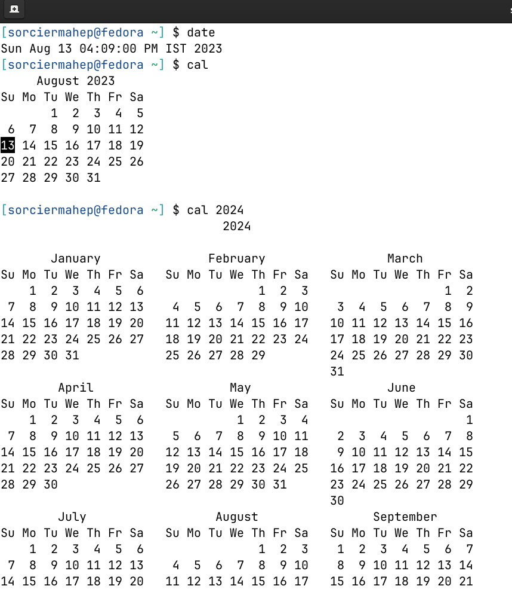

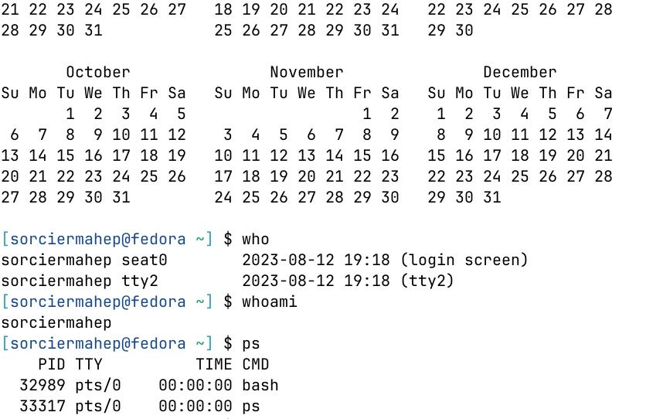

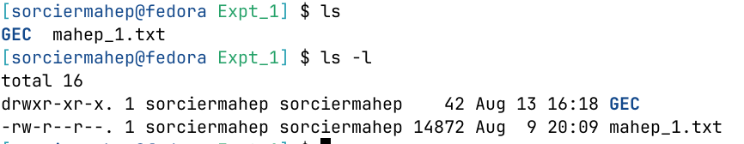 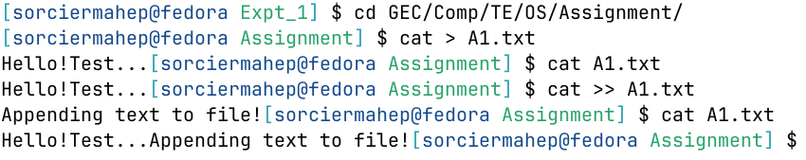 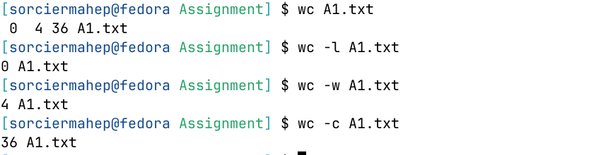

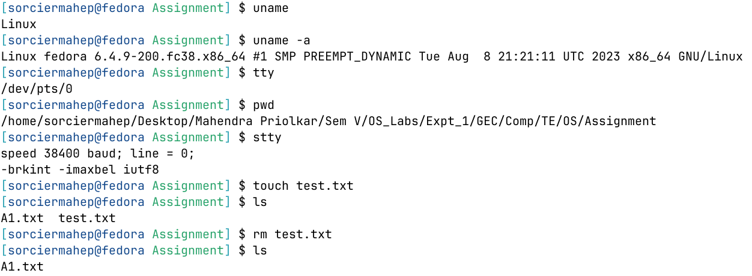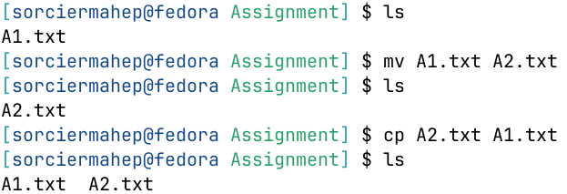

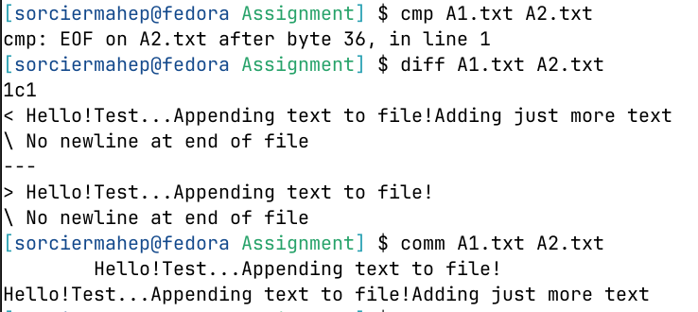

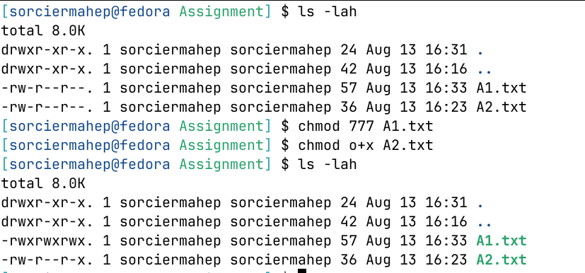

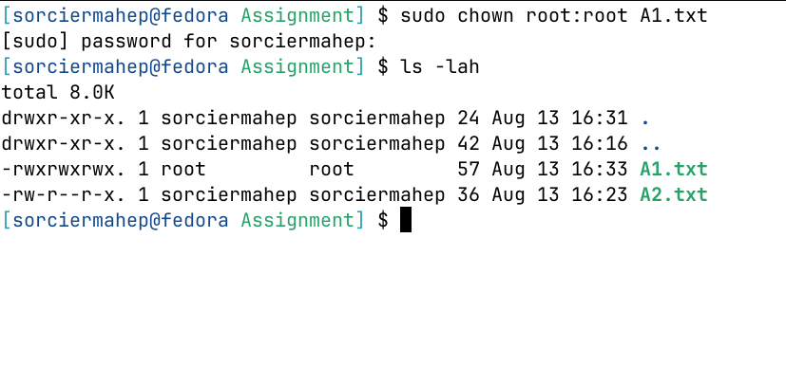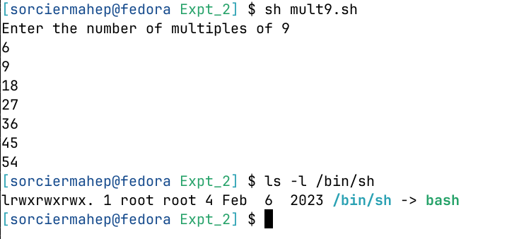

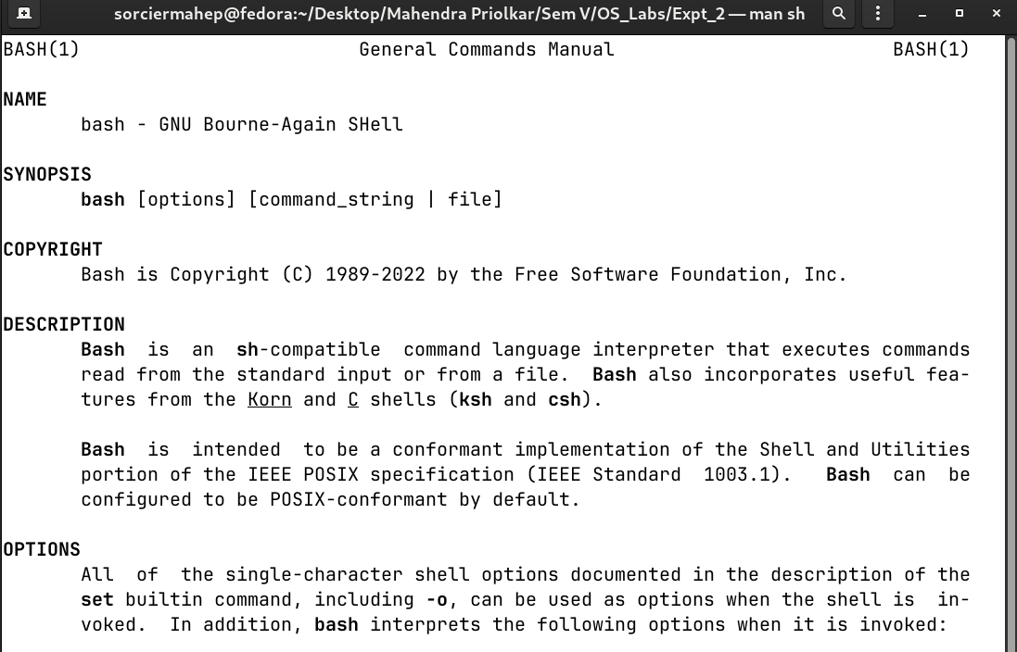

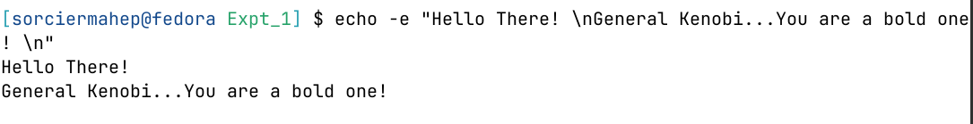

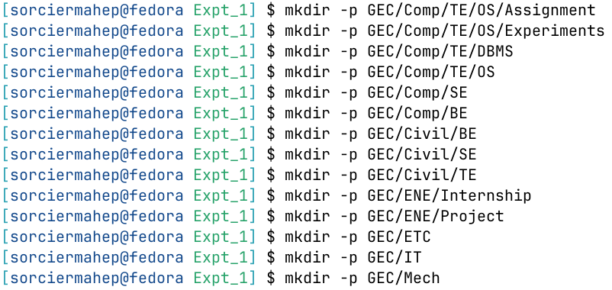

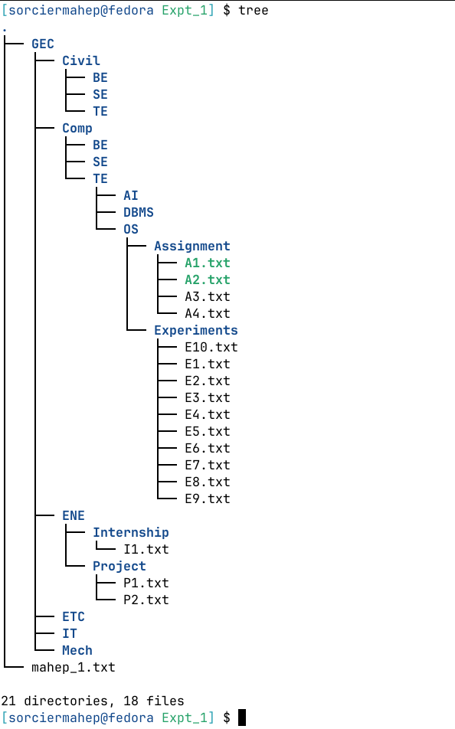

**Conclusion:** The Linux commands were studied and executed successfully.